Sequential Workflows in LangGraph
We will discuss sequential workflow in Langraph by creating a basic BMI Calculator.
Code:- here we created State named BMIState of typeDict type. We also created node calculate_bmi. START, END is basically there to tell start and end of our graph making it easy to have reference as we will see.
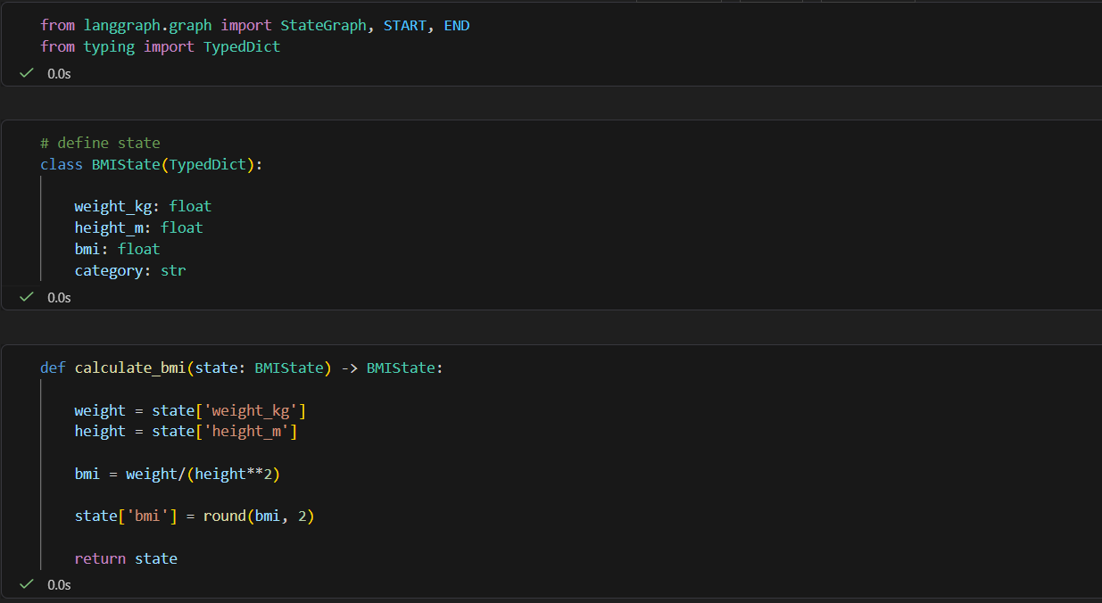

We then create the second node called label_bmi. And we defined our graph as graph using stategraph function with BMIState as input. We then add nodes to that graph. The structure is ( “ name of node “, name of function for the node ). We then add edges and we used START and END here to have a base to start and end. graph.compile() takes the graph you have defined (nodes + edges + state) and turns it into an executable workflow. We can now give it input values to start the process.
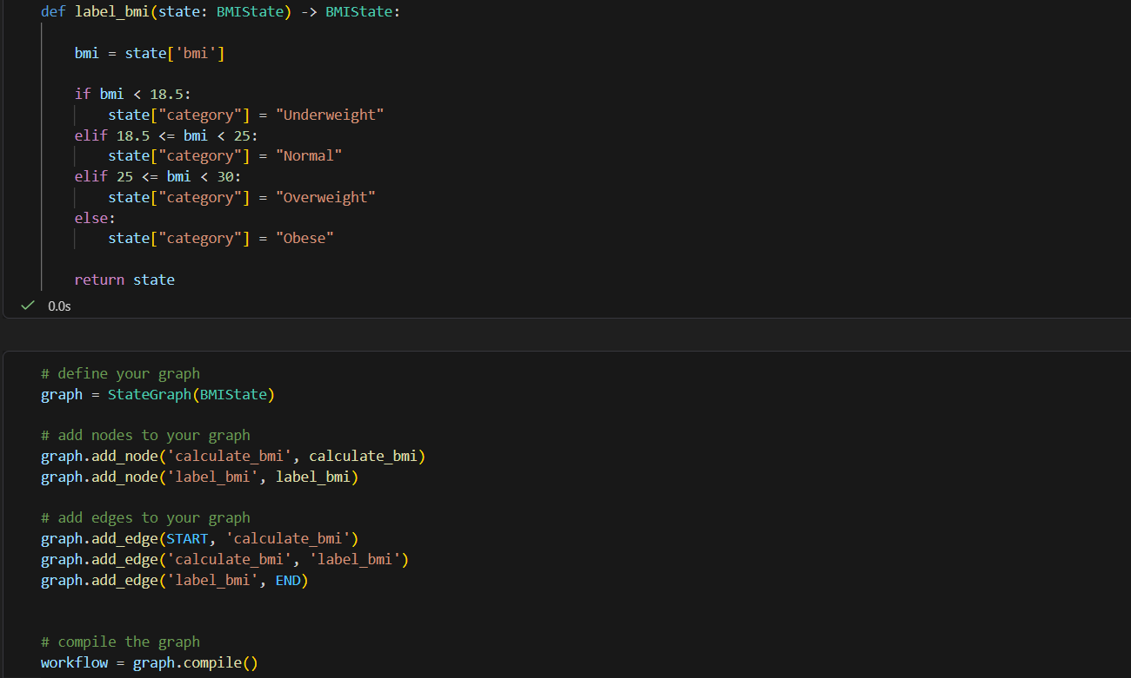

Here we give values and get a typeDict object in return to print. Last image shows the flow.
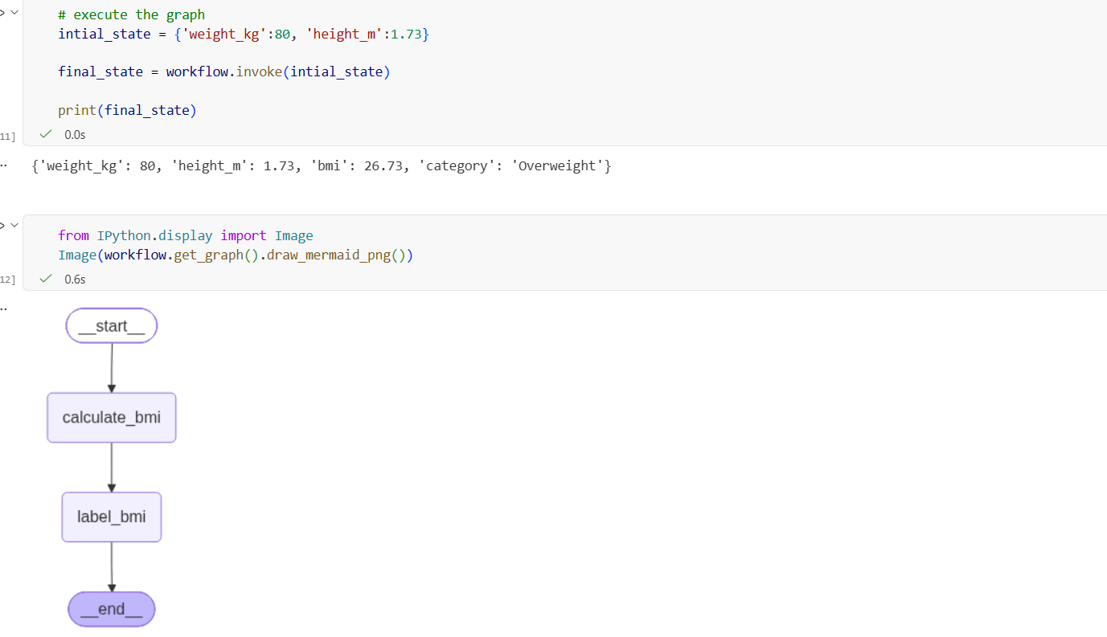

This is a simple Q and A where we ask LLM a question and it responds we update that into state.
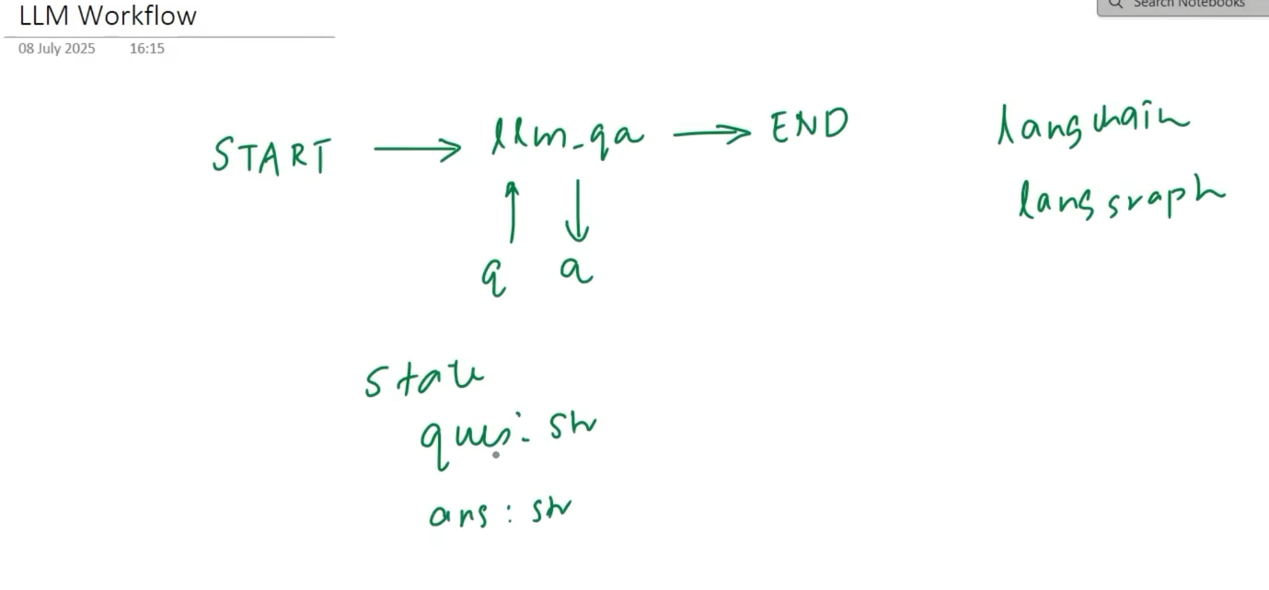

Code:-
We are using langchain to call the model. We also create the state like before.
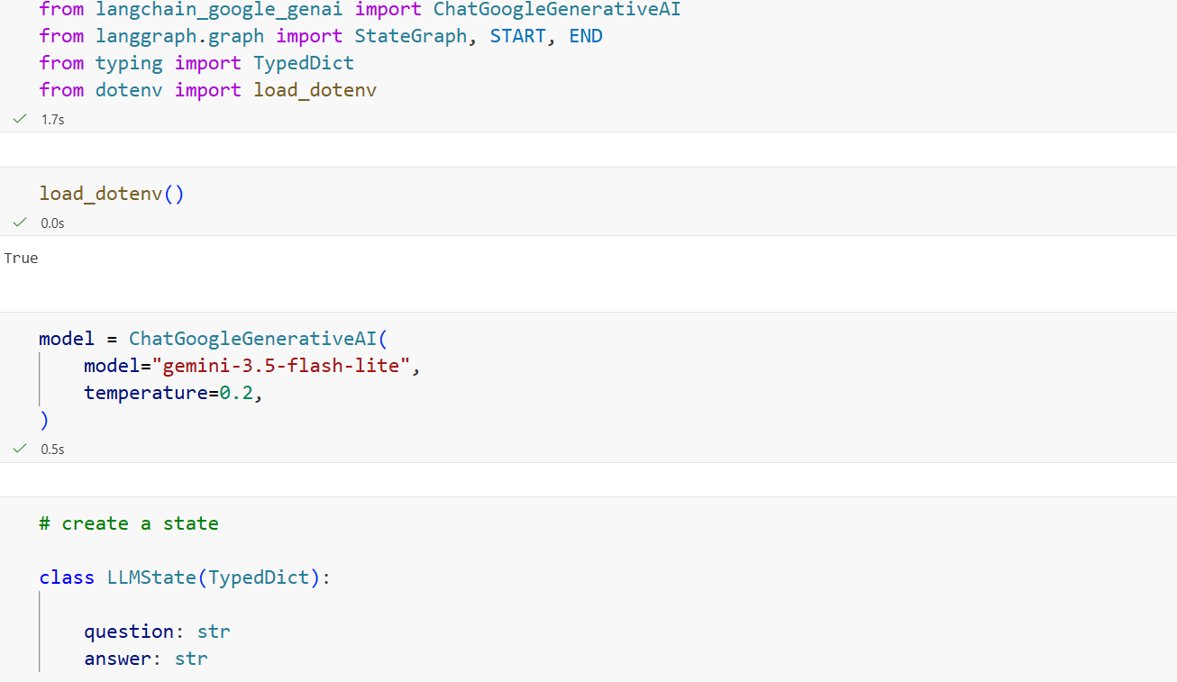
We take the question input from the state which is of typeDict and then we created a primpt for that. We then invoked the prompt to get an answer. We updated the answer we got from the LLM into answer of state and return the state like before.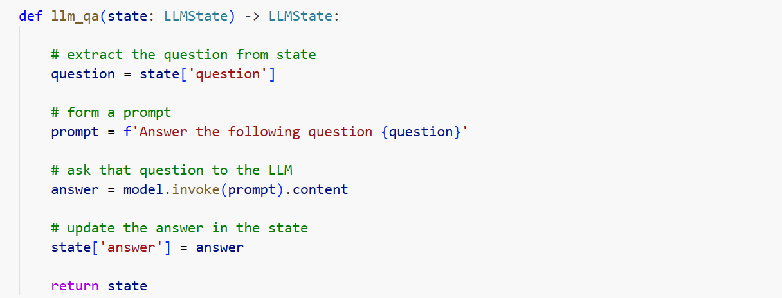

We created the StateGraph object called graph and added nodes and edges into it and created an object of graph called workflow and we invoked that workflow to give the question. Since it needs key-value pair, we give it in that format.
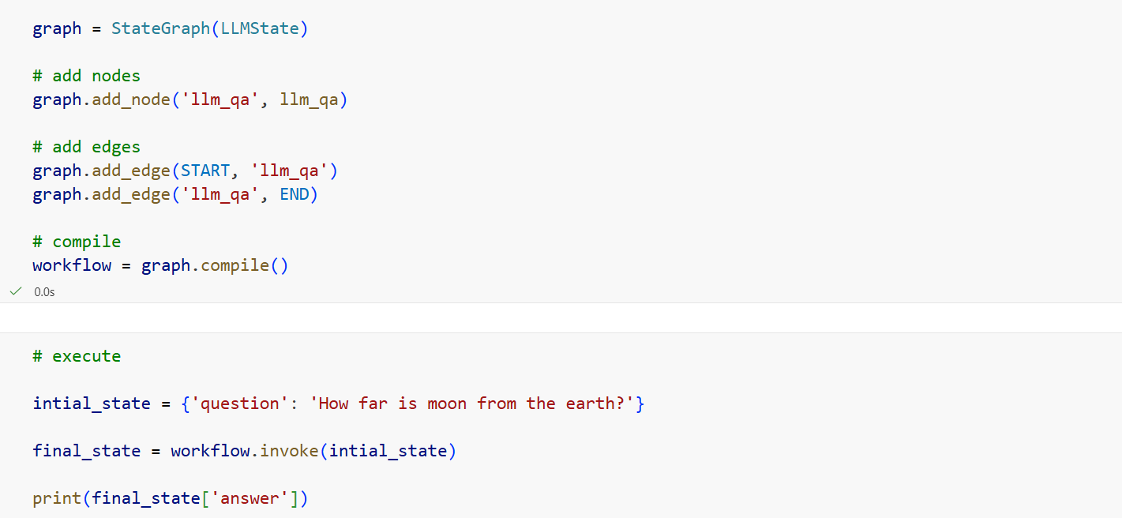

model.invoke('How far is moon from the earth?').content – the entire thing was same as this small piece of code but we did to see how to use langraph.
We are generating a blog and we are calling LLM twice here. Once for outline of blog and then for the blog itself. We also added an evaluation feature later on.
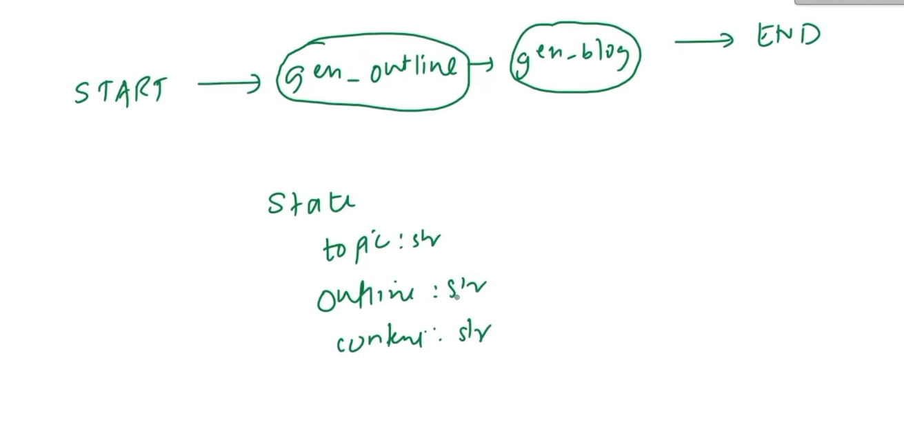

Code:- There is no much difference except we called the LLM thrice here in each of these functions and then we returned those values after updating the state variable.
